Lepton and Kirkheaton Surgeries Patient Participation Group AGM
Monday 4th December 2017
Present: Jacqui Yates, Mark Wall, Gordon Davies, Leslie Arragon, Marjorie Beaumont, Marcus Beaumont, Jill Robson, Jean Claude Arragon, Annette Day, M McCormack, D Haywood, G Briggs, P Clay, David Robb, John Carter, Steven Asalu, Ruth Harris
Apologies: Jenny Spencer
Presentation of annual reports
1 Chair
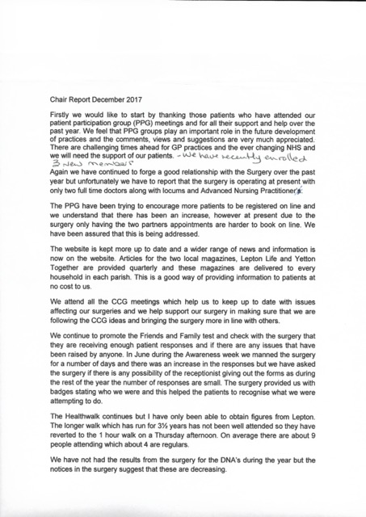
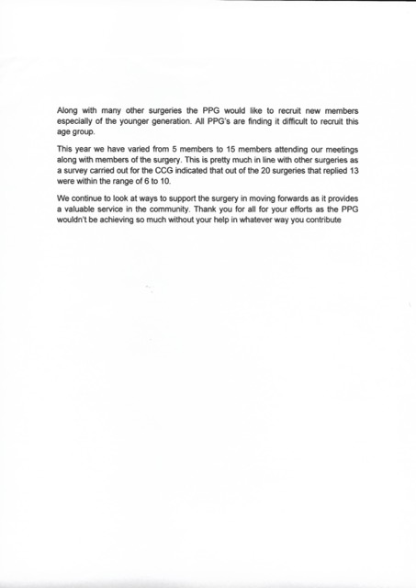
2. Treasurer
The account balance is £365.04 which is the same as last year, as yet we have been unable to find a suitable project to spend this amount on.
3. Membership Secretary
We have a few new faces and membership now stands at 32. It is still difficult to recruit younger members.
4. Election of committee
Action chair – David Robb
Treasurer – Ruth Harris
Minutes secretary – Peter Clay
Membership secretary – Jacqui Yates
CCG Representatives – David Robb and Jill Robson
5. AOB
None

